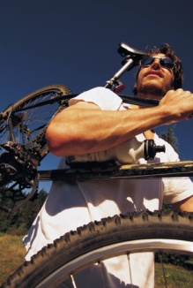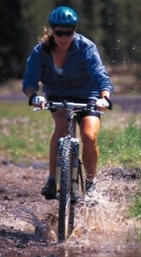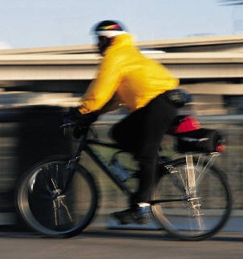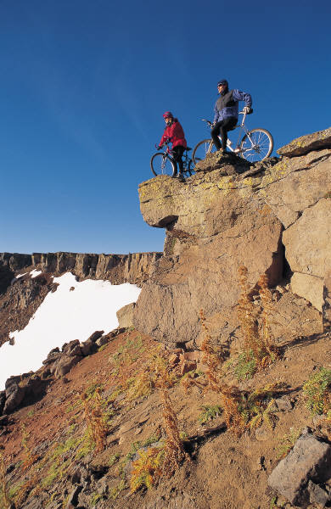

When: 2/15/15 – 2/25/15

Where: Vail, CO

Price: $1200

Who: You!

555.444.3333

# VAIL Biking Tour

### Quest specialty Travel presents…